Lab Task # 6
Q1. Write a program that repeatedly asks the user to enter a number and displays the entered number. The loop should continue until the user enters -1, at which point the program should display a message indicating the end of the program.
Solution:
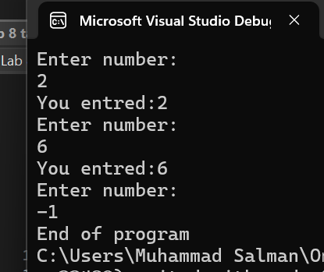
#include <iostream>
using namespace std;
int main() {
int n = 0;
while (n != -1)
{
cout << "Enter your number:\n";
cin >> n;
if (n != -1)
cout << "You entred:" << n << endl;
}
cout << "End program";
return 0;
}

Q2. Write a program using a do-while loop and while to print a square pattern of stars (*) of size 5x5.
Solution:
Using While Loop First:
#include<iostream>
using namespace std;
int main() {
int i = 1;

while (i<=5)
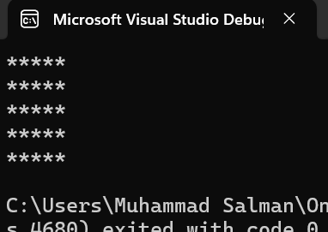
{
int j = 1;

while (j <= 5)
{
cout << "*";
j++;
}
cout << endl;
i++;
}
return 0;
}

Using do-While Loop:
#include<iostream>
using namespace std;
int main() {
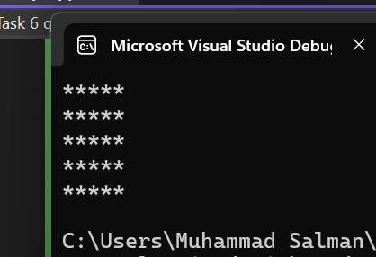
int i = 1;
do {
int j = 1;
do {
cout << "*";
j++;
} while (j <= 5);
cout << endl;
i++;
} while (i <= 5);
return 0;
}

